How to get to the GES 116
Sign into E-Services, then select “Online Learning” then “Learning Management System”
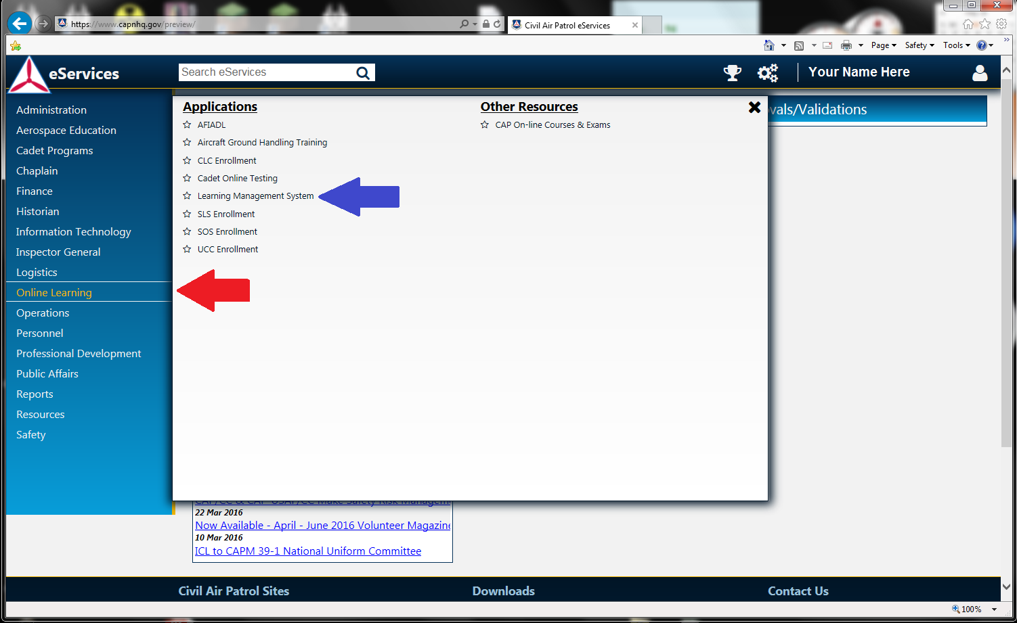
Scroll down and select “CAP116 - General ES – September 2008” under Emergency Services.
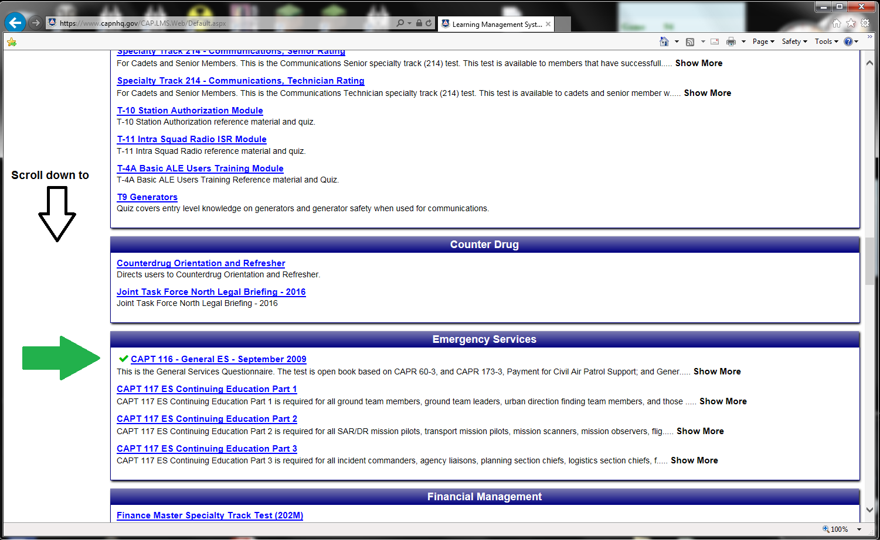
Open the two links to 60-3 and 173-3 in separate windows and Read. Then take the test. "THIS IS AN OPEN BOOK EXAM" take advantage of it. Open the digital version in its own tab and use the Control "Find" feature (Ctrl + F) to help. Be sure and click the next button if the first word it finds doesn’t help you find answer the question.
